**Group 10 Project 2**

**Members:** Patricia Mobolade, David Martinez, Roberto De La Torre, Josh Bond

**Project:**

US Firms by size, industry, payroll, and number of employees by state.

Rationale:

With the current push to support small businesses in the United States today. It begs the question, how much do small businesses contribute to the US sector in comparison to the "Amazons", "Googles" of the world? How has it varied over time? What sectors do small business tend to gravitate to? On average, do employees in larger enterprises earn more per capita than small businesses?

**Data sources:**

**Lookup Dimension Dataset**

2017 NAICS Structure Summary Table   
<https://www.census.gov/eos/www/naics/2017NAICS/2017_NAICS_Structure_Summary_Table.xlsx>

**Main Dataset**

Statistics of U.S. Businesses (SUSB) Data Tables by State and Establishment Industry (NAICS Sectors) from 2008 -2017  
<https://www2.census.gov/programs-surveys/susb/tables/2008/state_naicssector_2008.xls>  
<https://www2.census.gov/programs-surveys/susb/tables/2009/state_naicssector_2009.xls>  
<https://www2.census.gov/programs-surveys/susb/tables/2010/state_naicssector_2010.xls>  
<https://www2.census.gov/programs-surveys/susb/tables/2011/state_naicssector_2011.xls>  
<https://www2.census.gov/programs-surveys/susb/tables/2012/state_naicssector_2012.xls>  
<https://www2.census.gov/programs-surveys/susb/tables/2013/state_naicssector_2013.xls>  
<https://www2.census.gov/programs-surveys/susb/tables/2014/state_naicssector_2014.xlsx>  
<https://www2.census.gov/programs-surveys/susb/tables/2015/state_naicssector_2015.xlsx>  
<https://www2.census.gov/programs-surveys/susb/tables/2016/state_naicssector_2016.xlsx>  
<https://www2.census.gov/programs-surveys/susb/tables/2017/state_naicssector_2017.xlsx>

**Sample Visualizations:**

Visuals will be a color intensity to be gauged by industry, size and revenue that can be filtered by year.

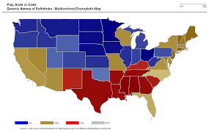

A scatter plot sized by number of employees, showing state, with axes by per capita employment and total revenue. Will have a slider to show variations by year.

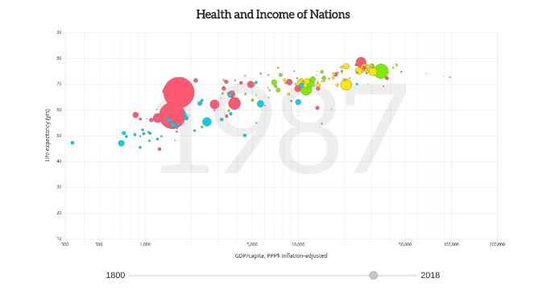

If good observable trends or interesting data is observed bar charts or line graphs will be used to detail those.

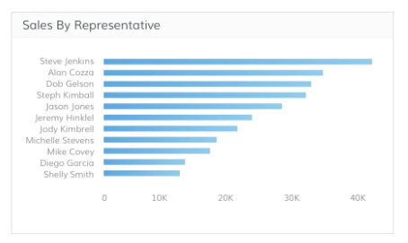

**Design Sketch:**

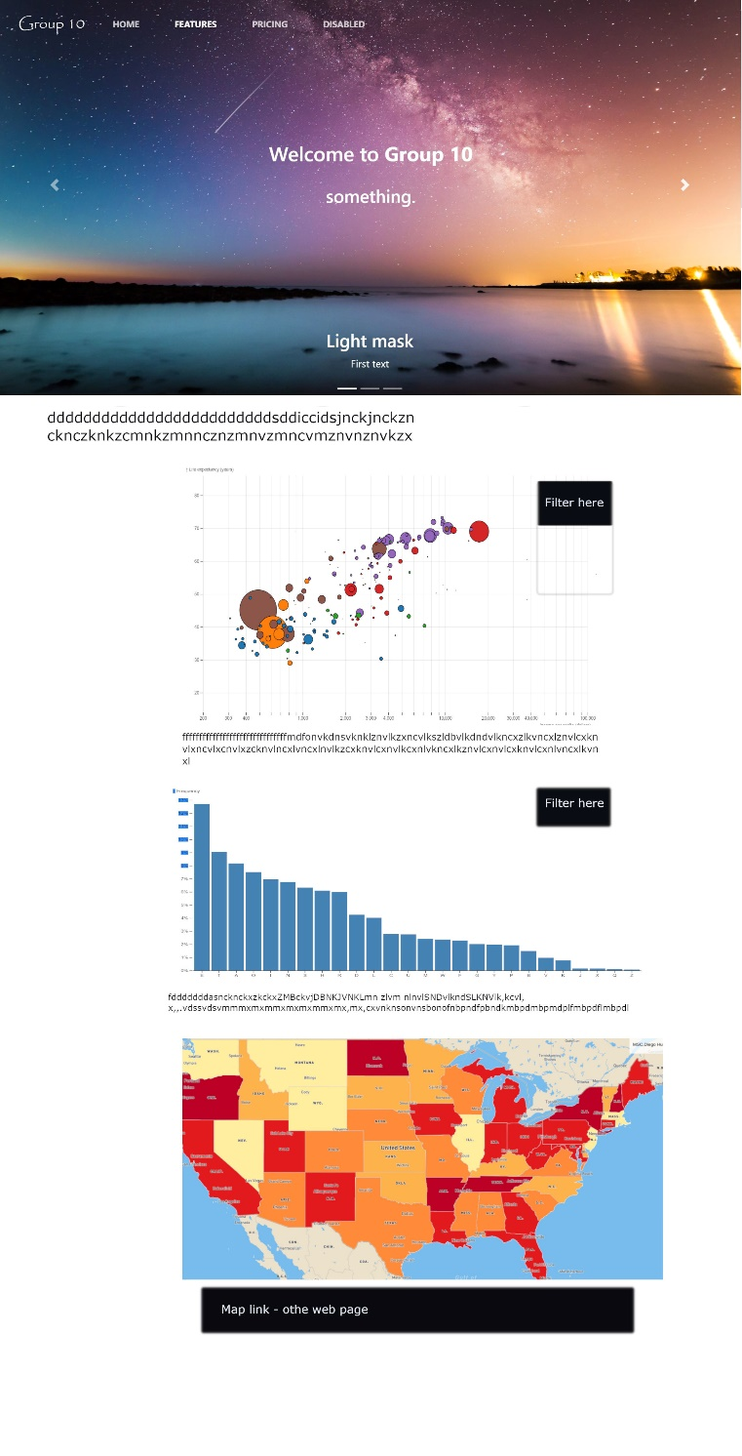

**Repo Link:**

<https://github.com/jobongie/group10_project2>